
Lab: Interpreting and Matching
Displacement vs. Time Motion Graphs

Objectives:
- Create a Displacement vs. Time graph and match your graph with actual motion.
- Gain competence in the use of motion detector and related equipment.
- Understand the relationship between position vs. time, velocity and acceleration.

Materials:

TI-84 Calculator-Based Lab Unit (CBL-II)

Motion detector

Meter stick

Computer with LoggerPro software

Procedure:

Part I –
- Develop a position vs. time story that describes a body in motion incorporating at least the following four types of motion.
    - standing still
    - moving with constant velocity
    - moving with variable negative velocity
    - moving with variable positive velocity
- Illustrate the story on a position vs. time graph. Use a legend to cross reference sections of the graph with the corresponding sections of the story.
- Underneath the graph, write instructions for moving in front of the motion detector according to the graph you have drawn (see page 2 for example).

Part II – AT THE LAB STATION IN CLASS WITH A PARTNER
4. Measure out and mark meaningful locations on the floor and practice the motion needed to create the position vs. time graph.

5. Now it’s time for you to match your physical motion to your group’s descriptive motion graph. You have 3 attempts to match it as best you can. Save a copy best graph your motion creates and reproduce this graph using LoggerPro.

Data:

Story:
The bell rings and Boris begins walking to class. He went 40m in 1 minute. He stops for 30 seconds because he remembers he left his books in his class. He runs back in 30 seconds, getting faster along the way. He stops for another 30 seconds to collect his books and runs back to his next class, realizes he has plenty of time left, and slows down.

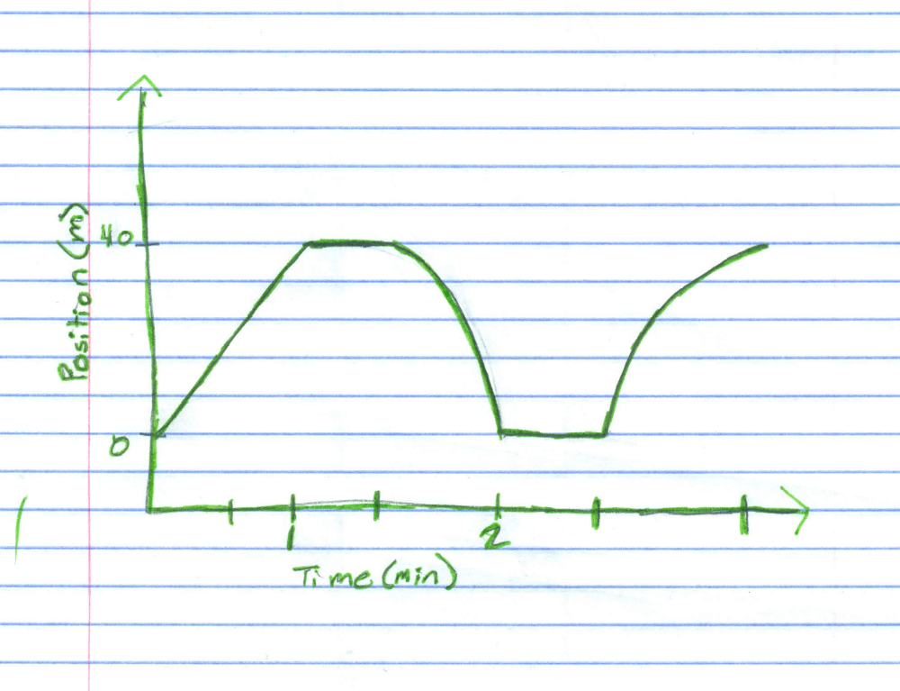

Key: 1 sec = 15 sec
1 m = 20 m

Time (sec) Position (m)
0.1 0.124391
0.2 0.134387
0.3 0.169372
0.4 0.209077
0.5 0.247949
0.6 0.29765
0.7 0.358457
0.8 0.422041
0.9 0.482293
1 0.530605
1.1 0.575308
1.2 0.616402
1.3 0.653053
1.4 0.692203
1.5 0.734962
1.6 0.785496
1.7 0.846858
1.8 0.915162
1.9 0.977358
2 1.03678
2.1 1.08426
2.2 1.13784
2.3 1.17505
2.4 1.22059
2.5 1.26196
2.6 1.3136
2.7 1.37052
2.8 1.43133
2.9 1.48769
3 1.54323
3.1 1.59709
3.2 1.63485
3.3 1.67345
3.4 1.71121
3.5 1.74842
3.6 1.79562
3.7 1.83893
3.8 1.88141
3.9 1.93195
4 1.97693
Time (sec) Position (m)
4.1 2.01636
4.2 2.0369
4.3 2.05773
4.4 2.06856
4.5 2.06856
4.6 2.07605
4.7 2.08022
4.8 2.08272
4.9 2.08438
5 2.08188
5.1 2.08188
5.2 2.08299
5.3 2.0866
5.4 2.08549
5.5 2.08771
5.6 2.08744
5.7 2.08744
5.8 2.08272
5.9 2.07827
6 2.07494
6.1 2.05301
6.2 2.03052
6.3 1.98415
6.4 1.93667
6.5 1.8778
6.6 1.80173
6.7 1.72731
6.8 1.64402
6.9 1.54239
7 1.40801
7.1 1.28223
7.2 1.14784
7.3 0.995961
7.4 0.834641
7.5 0.668046
7.6 0.534493
7.7 0.430093
7.8 0.345129
7.9 0.276548
8 0.230179
8.1 0.202968
Time (sec) Position (m)
8.2 0.184921
8.3 0.174092
8.4 0.167983
8.5 0.163818
8.6 0.160209
8.7 0.158265
8.8 0.156599
8.9 0.156044
9 0.155489
9.1 0.155489
9.2 0.156044
9.3 0.157155
9.4 0.158265
9.5 0.160209
9.6 0.162153
9.7 0.158265
9.8 0.152157
9.9 0.170205
10 0.236287
10.1 0.340409
10.2 0.458414
10.3 0.570588
10.4 0.692203
10.5 0.809097
10.6 0.947093
10.7 1.09397
10.8 1.22642
10.9 1.34692
11 1.46409
11.1 1.5671
11.2 1.64707
11.3 1.72704
11.4 1.7995
11.5 1.87003
11.6 1.93306
11.7 1.99137
11.8 2.04662
11.9 2.09882
12 2.13436

Variable Motion
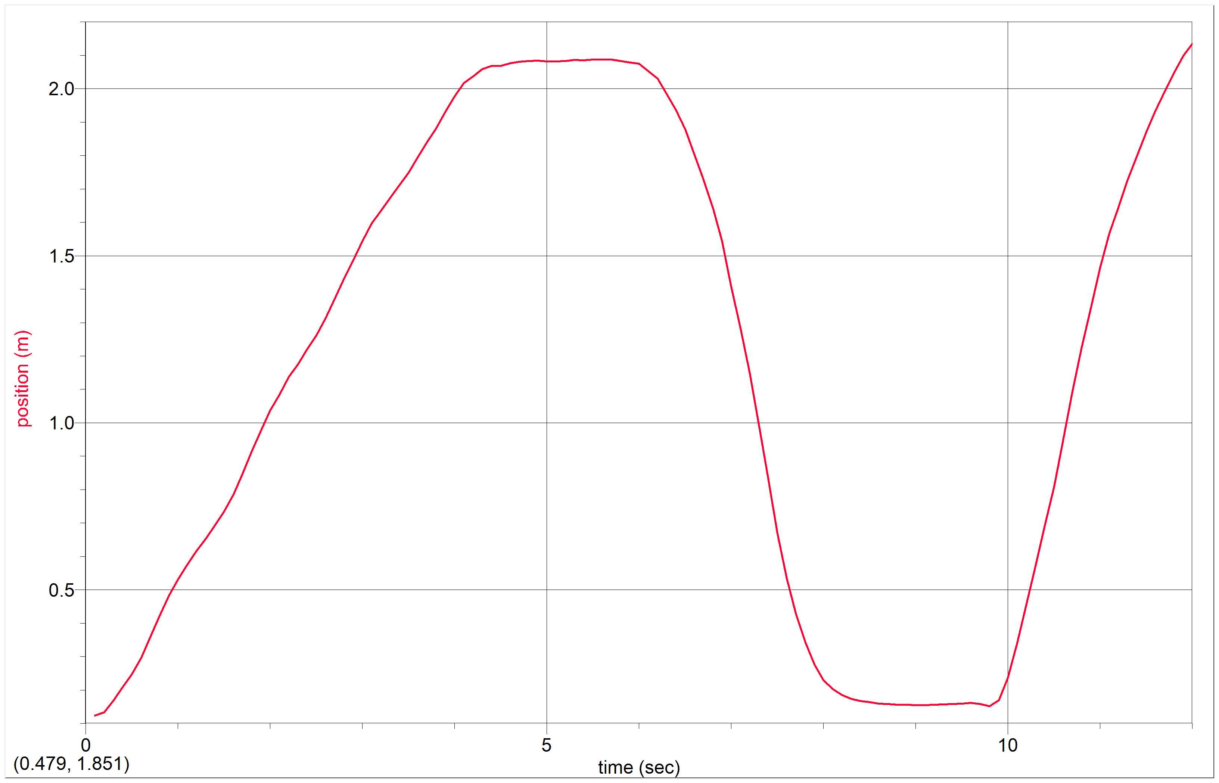

Motion instructions:
A) Face the sensor, holding a book in front of it 4 cm.

B) For the first four seconds, walk backwards away from the motion sensor with slow constant velocity and stop 2.0 m from the sensor.

C) Stand still for two seconds.

D) Walk toward the sensor, speeding up, and arrive 4 cm in front of the sensor after two seconds.

E) Stand still for two seconds.

F) Quickly walk backwards, slowing down, and arrive 2.0 m from the sensor after two seconds. Stop collecting data.

Data Analysis: Discuss differences between the descriptive graph and the graph generated by the motion detector. What are the reasons for the differences?
The descriptive graph displays the ideal graph of the motion of the story with no errors. The graph generated by the motion detector represents an attempt to recreate the motion of the descriptive graph, and thus has some errors. This is because of experimenter error, such as not moving the correct distance and not moving at the exact time. Also, a scale had to be used, allowing for more room to make mistakes.

Conclusion: Develop a conclusion that addresses the objectives of the lab.

The descriptive graph was created according to a story to represent variable motion. The actual motion graph was created by use of a motion detector and calculator. A scale was used to represent the distances in the story, and multiple trials were needed to create a graph that closely resembled the descriptive graph. Due to experimenter error, the graph was not identical to the descriptive graph, but was useful for showing the types of motion. The graph is a position graph. As time varies with x, the y-values correspond to the position of the particle. The slope of the line at any given point is the particle’s instantaneous velocity. When the position line has a constant slope, the particle has zero acceleration. Acceleration is the rate at which the velocity is changing. Acceleration can be viewed on the graph with a curved position line. When position is decreasing, the velocity is negative, and when position is increasing, the velocity is positive. When the slope of a curved line approaches zero, the acceleration is decreasing, and when the slope is getting larger, the acceleration is increasing. The combination of initial position, velocity, and acceleration determines the position of the particle.

